# **Deep Learning Architecture for Healthcare IOT**

# **Dr. Hemanth K S**

School of Computer Science Applications,

REVA University, Bengaluru, INDIA

[hemanth.k@reva.edu.in](mailto:hemanth.k@reva.edu.in)

# **Prathamesh Pradeep Dessai**

School of Computer Science Applications,

REVA University, Bengaluru, INDIA [prathameshdessai6801@gmail.com](mailto:prathameshdessai6801@gmail.com)

# **Nikhil B**

School of Computer Science Applications,

REVA University, Bengaluru, INDIA

[nikihilkumar](mailto:nikihilkumar)[123@gmail.com](mailto:123@gmail.com)

# **S. Senthil**

School of Computer Science Applications,

REVA University, Bengaluru, INDIA [senthilofficial.sskm@gmail.com](mailto:senthilofficial.sskm@gmail.com)

# **Abstract**

# This exploration specializes in incorporating deep gaining knowledge of architectures with Healthcare Internet of Things (IoT). The method starts off evolved by way of measuring the effect of deep learning on healthcare metrics, specializing in enhanced diagnoses, decrease charges, and the implementation of tailor-made medicinal drug to address troubles consisting of early ailment prognosis. Exploring DL in Healthcare IoT entails ethical questions, regulatory challenges, and the opportunity for scalability and interoperability. It covers essential components of Healthcare IoT, categorizing sensors, discussing information accumulating strategies, and emphasizing information safety and privacy precautions. Deep learning packages require a radical know-how of artificial neural networks, convolutional neural networks, recurrent neural networks, autoencoders, and generative opposed networks. The examine investigates numerous Deep Learning packages in healthcare, together with medical image evaluation, time collection analysis, healthcare chatbots, and remote patient monitoring. It offers an overview of the way Deep Learning is applied to deal with difficulties and chart destiny traits inside the Healthcare IoT space.

***Keywords: -*** Deep learning (DL), Healthcare IoT, Artificial Neural Networks (ANN), Convolutional Neural Networks (CNN), Recurrent Neural Networks (RNN), Generative Adversarial Networks (GANs), and Medical Image Analysis.

**1. Introduction**

Internet of Things (IoT) technologies have transformed the patient care and medical research landscape, through remote monitoring, personalized treatment, and data infusion. The hardest challenge of all in healthcare IoT is maintaining both privacy and security over patients sensitive data whilst benefiting from the shared intelligence coming out of the integration distributed devices to be able to train a joint model That’s where federated learning comes in — an emerging paradigm that aims to counteract this trend by enabling multiple parties to collaboratively construct machine-learning models without sharing any raw data. Federated learning provides an approach to privacy preservation in healthcare IoT applications, as by keeping data local and utilizing secure aggregation, guarantees the security of the information [5][6]. This decentralized learning architecture not only supports the federated mode of model training across different healthcare facilities, but also ensures personalized health services and real-time monitoring as well as complies with the regulation. In conclusion, as the healthcare industry undergo digital transformation in the coming years, federated learning in healthcare IoT may offer an executable strategy to catalyze innovation that will enhance patient outcomes and ultimately redefine data-driven best practices while adhering to stringent privacy and security standards [26][27].

**1.1 Revolutionizing Healthcare: The Impact of Deep Learning**

The usage of deep learning in healthcare has delivered about a transformative shift within the clinical panorama, notably enhancing diagnostic talents and cost effectiveness in the enterprise. Deep learning algorithms have proven to be instrumental in improving the accuracy and efficiency of diagnoses, main to extra particular and timely identity of scientific situations. Deep gaining knowledge of models may additionally find out tiny styles and abnormalities that popular diagnostic procedures may additionally miss, reworking the prognosis manner and permitting healthcare carriers to make extra confident, educated conclusions [24][25].

Moreover, the combination of deep learning in healthcare has also contributed to value discount by streamlining techniques, optimizing useful resource allocation, and minimizing pointless approaches. By automating duties, improving predictive analytics, and facilitating early disorder detection, deep learning technology has the potential to lower healthcare fees even as improving patient outcomes. These improvements now do not best gain healthcare vendors by means of growing operational performance but additionally result in higher outcomes for patients through more accurate diagnoses and tailor-made treatment plans [17][18].

In addition to advances in analysis and fee reduction, deep getting to know in healthcare is actively addressing several industrial issues, including early contamination detection and tailor-made therapy. Healthcare structures may also use deep learning algorithms to stumble on illnesses in their early levels, bearing in mind activate remedies and enhancing affected person results. Furthermore, deep mastering's ability to assess and realize massive volumes of patient facts allows the modification of treatment regimens based totally on man or woman features, ensuing in extra tailored and effective healthcare treatments. These programs of deep gaining knowledge of underscore its potential to revolutionize healthcare with the aid of addressing essential demanding situations and improving the exceptional of affected person care [11][12][13].

**1.2 Navigating Challenges and Opportunities in Healthcare IoT**

Navigating the complicated environment of Healthcare IoT problems and opportunities is essential for making certain the powerful integration of technology within the healthcare industry. Ethical troubles and records privateness are important problems within the improvement and implementation of IoT systems in healthcare. Protecting patient statistics privacy and confidentiality is critical for organizing acceptance as true among healthcare specialists and patients. Ethical issues also make bigger to addressing ability biases in algorithms used in IoT systems to make sure truthful and unbiased choice-making approaches, particularly in healthcare settings where the consequences of mistakes can be extensive [3][4][30].

Regulatory hurdles present any other vast project in the implementation of Healthcare IoT solutions, with healthcare companies desiring to conform with a myriad of rules which include HIPAA, GDPR, and FDA suggestions. Ensuring regulatory compliance is vital to shield affected person data, maintain the integrity of healthcare systems, and avoid prison repercussions. Overcoming those regulatory hurdles requires a complete knowledge of the prison frameworks governing healthcare statistics and the implementation of robust security measures to guard sensitive facts [17][18].

Furthermore, ensuring scalability in Healthcare IoT systems is crucial for accommodating the growing extent of facts generated with the aid of related devices and packages. Scalability allows healthcare agencies to expand their IoT infrastructure to meet developing demands even as maintaining performance and reliability. By designing scalable IoT solutions, healthcare providers can efficaciously control and examine massive datasets, put into effect real-time tracking and analytics, and supply personalized care to patients [14].

Healthcare firms may realize the full potential of IoT technology by resolving ethical problems, data protection concerns, overcoming regulatory challenges, and assuring scalability [7][8][9].

**1.3 Chapter Overview**

The chapters in this exploration of Deep Learning Architecture for Healthcare IoT cowl a wide variety of essential subjects. The creation sets the degree through highlighting the transformative effect of integrating IoT technologies in healthcare, emphasizing far flung monitoring, personalized remedy, and statistics-pushed insights. The subsequent chapters delve into the software of deep gaining knowledge of in healthcare metrics, that specialize in improved diagnoses, value reduction, and tailored medicine for early sickness detection. Ethical issues and regulatory challenges are thoroughly discussed, underscoring the importance of safeguarding patient statistics privateness, addressing biases in algorithms, and ensuring compliance with guidelines like HIPAA, GDPR, and FDA recommendations. The exploration also touches on the need of scalability and interoperability in integrating deep getting to know fashions into massive-scale healthcare systems and IoT ecosystems. Future instructions encompass enhancing the interpretability of deep studying models through explainable AI, participating with regulatory organizations to promote ethical AI packages, and developing guidelines for compliance with healthcare rules. The chapters also highlight the significance of personalized medicine enabled through superior deep getting to know algorithms, the combination of deep getting to know fashions with edge computing for actual-time analysis and superior privateness, and the moral issues surrounding AI in healthcare. Multimodal statistics fusion is discussed to combine facts from diverse assets for comprehensive contamination prognosis and personalized healthcare management. Overall, the chapters offer a comprehensive evaluation of the applications, demanding situations, and future enhancements of deep mastering in healthcare IoT, emphasizing the want for collaboration, ethical concerns, regulatory compliance, and patient-centric care to force innovation and improve affected person consequences within the healthcare enterprise.

**2. Background**

**2.1 Foundations of Healthcare IoT**

In the realm of Healthcare IoT, the foundation lies in the categorization of sensors and devices, which play a pivotal position in capturing and transmitting critical fitness data for monitoring and evaluation. Sensors in healthcare IoT may be categorized into diverse classes based on their functionality, together with physiological sensors (measuring vital signs and symptoms like coronary heart price and blood strain), environmental sensors (tracking factors like temperature and humidity), and interest sensors (monitoring motion and hobby levels). These sensors are included into wearable devices, clinical systems, and clever infrastructure to gather actual-time information on sufferers' fitness repute and environmental situations [26][27].

Data acquisition in Healthcare IoT includes the manner of collecting facts from sensors and devices, that is then transmitted to centralized structures for evaluation and interpretation. This statistics acquisition section is critical for producing insights into patient health, enabling early detection of abnormalities, and facilitating personalized healthcare interventions. Communication protocols which include Bluetooth, Wi-Fi, and cell networks are utilized to transmit statistics securely and efficaciously between devices and healthcare structures, ensuring seamless connectivity and real-time tracking competencies [1][2].

Ensuring the security of healthcare IoT information is important for protecting patient privacy, preserving records integrity, and stopping undesirable entry to touchy data. Data at rest and in transit is protected by using sturdy protection techniques such as encryption, authentication processes, and get entry to manipulate policies. Compliance with regulatory necessities consisting of HIPAA and GDPR is vital for reducing security risks and protecting affected person confidentiality in healthcare IoT systems.

By categorizing sensors and devices, optimizing statistics acquisition procedures, setting up steady communication protocols, and enforcing stringent safety features, Healthcare IoT structures can efficaciously harness the power of related technologies to beautify patient care, enhance clinical effects, and pressure innovation inside the healthcare enterprise [24][25].

**2.2 Fundamentals of Deep Learning**

In the world of deep learning, Artificial Neural Networks (ANNs) function as the foundational building blocks for modeling complicated relationships in facts [17][18]. ANNs are stimulated by using the shape and feature of the human mind, that is made of linked nodes grouped into layers. Each node strategies incoming facts applies weights and biases, and then sends the results through activation capabilities to produce predictions or classifications. ANNs excel in pattern identification, regression analysis, and class, making them useful gear in several fields, including healthcare, finance, and photograph recognition.

Convolutional Neural Networks (CNNs) are a specialized form of neural networks designed for processing grid-like facts, which include pics and movies [7][8][9]. CNNs leverage convolutional layers to extract features hierarchically, pooling layers to down sample spatial dimensions, and fully related layers for category tasks. CNNs have transformed laptop imaginative and prescient packages by using acting tasks including item identification, photo segmentation, and facial recognition with amazing accuracy and efficiency [29].

Recurrent Neural Networks (RNNs) are tailor-made for sequential statistics processing, making them perfect for duties related to time series analysis, herbal language processing, and speech recognition [17][18]. RNNs use inner memory to document temporal relationships in information, allowing context-aware predictions and dynamic sequence modeling. Applications of RNNs range from language translation and sentiment evaluation to inventory market forecasting and scientific analysis.

Autoencoders represent a category of neural networks used for unsupervised studying and dimensionality discount [17][18]. Autoencoders goal to reconstruct enter records on the output layer, mastering green representations or latent variables in the manner. By compressing and decompressing data, autoencoders discover applications in anomaly detection, feature extraction, and records denoising tasks.

Generative Adversarial Networks (GANs) are a progressive framework for training generative fashions that pits neural networks in opposition to each different: a generator and a discriminator [17][18]. The generator generates artificial information samples, and the discriminator assesses their authenticity, resulting in a competitive gaining knowledge of technique that improves the generator's output. GANs have helped create sensible visuals, improve information augmentation strategies, and enhance innovative programs in artwork and layout.

By expertise the intricacies of ANNs, exploring the abilities of CNNs, RNNs, Autoencoders, and GANs, practitioners can leverage the electricity of deep learning to address complicated troubles, force innovation, and liberate new opportunities in synthetic intelligence and machine learning.

**3. Deep Learning Architecture for Healthcare IOT**

**3.1 Revolutionizing Medical Image Analysis**

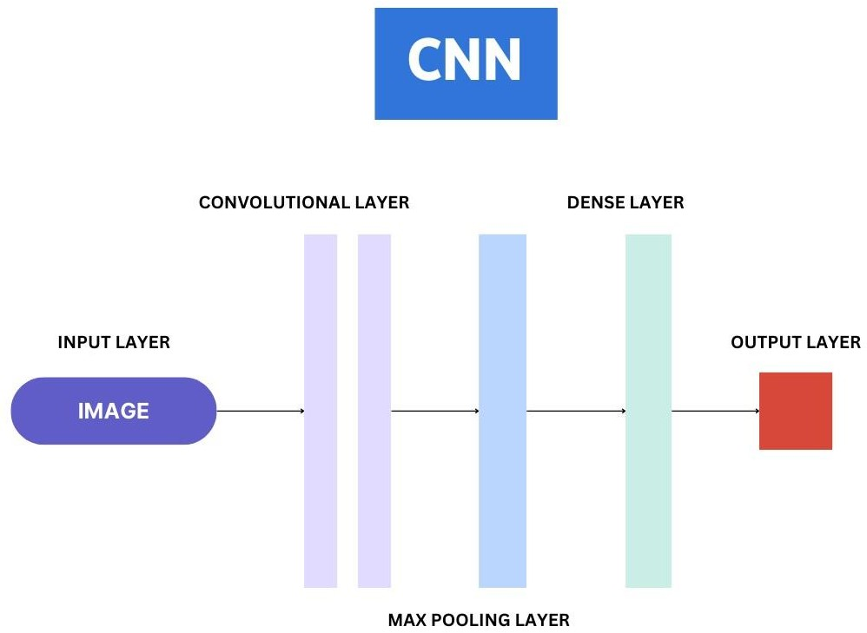

**Figure 3.1.1: CNN (Deep Learning Architecture in Medical Image Analysis)**

Revolutionizing clinical image evaluation involves superior strategies for classifying, segmenting, generating, and reconstructing medical pics, leveraging the strength of synthetic intelligence, and deep getting to know algorithms [11][12][13]. Classifying clinical pictures entails categorizing them into one-of-a-kind lessons or categories based totally on their visual capabilities and characteristics. Deep gaining knowledge of models, which include Convolutional Neural Networks (CNNs), have established first-rate performance in photograph type obligations, taking into consideration particular detection of ailments, abnormalities, or systems internal scientific pictures [11]. By schooling CNNs on categorized datasets, those models can examine to distinguish between diverse lessons of medical situations, assisting in analysis and treatment planning.

Segmenting medical pics involves partitioning them into significant regions or systems to extract specific records for analysis or visualization [11]. Techniques like semantic segmentation and example segmentation are used to delineate obstacles and pick out gadgets inside photos with pixel-degree accuracy. Tumor identity, organ localization, and anatomical measurements all gain from segmentation, which gives clinical practitioners with thorough statistics.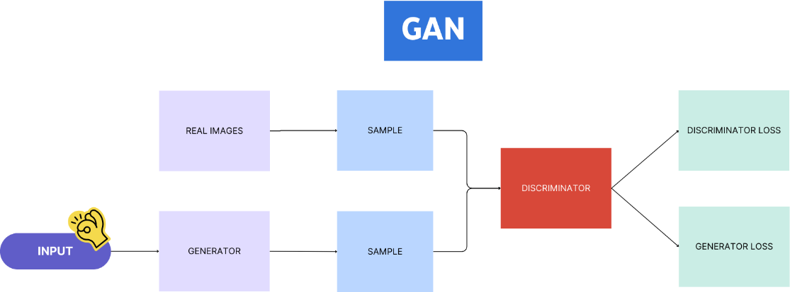

**Figure 3.1.2: GAN (Deep Learning Architecture in Medical Image Analysis)**

Generating and reconstructing clinical pics using deep mastering techniques have opened new possibilities for reinforcing photo satisfactory, filling in lacking statistics, and synthesizing sensible images for diagnostic purposes [11][12][13]. Generative fashions like Generative Adversarial Networks (GANs) can generate synthetic clinical images that carefully resemble actual patient statistics, facilitating information augmentation, anomaly detection, and training robust fashions. Additionally, image reconstruction strategies, along with autoencoders, permit the recuperation of degraded or incomplete clinical images, improving visualization and analysis for healthcare practitioners.

By integrating advanced algorithms for classifying, segmenting, generating, and reconstructing medical pics, healthcare experts can leverage contemporary technology to enhance diagnostic accuracy, streamline workflows, and improve patient effects in clinical imaging applications. The fusion of synthetic intelligence with medical photograph analysis holds vast capacity for remodeling healthcare practices and advancing the sphere of radiology and imaging sciences.

**3.2 Empowering Medical Time Series Analysis**

|  |  |
| --- | --- |
| **Aspect** | **Description** |
| Data Types | Electrocardiography (ECG), Electroencephalography (EEG), Blood glucose measurements |
| Objectives | Diagnosing cardiac conditions, Identifying arrhythmias, monitoring brain function |
| Techniques | Deep Learning, Time Series Forecasting, Attention Mechanisms |
| Applications | Heartbeat classification, Seizure detection, Blood glucose trend forecasting |
| Benefits | Early intervention for heart abnormalities, innovative diagnostic tools for neurological disorders, personalized diabetes management strategies |
| Challenges | Data variability and noise, interpretability of deep learning models, Limited annotated data |
| Tools & Frameworks | TensorFlow, Keras, PyTorch, scikit-learn, MATLAB |
| Evaluation Metrics | Accuracy, Sensitivity, Specificity, Mean Absolute Error, F1 Score |

**Table 3.2.1: Components involved in empowering medical time series analysis.**

Empowering clinical time collection evaluation involves leveraging superior strategies to extract treasured insights from sequential records along with electrocardiography (ECG), electroencephalography (EEG), and blood glucose measurements [14][15][16]. This time series information offers crucial data about physiological processes, brain hobby, and metabolic styles, allowing healthcare experts to monitor sufferers' fitness fame, stumble on abnormalities, and make knowledgeable scientific selections.

Analyzing ECG facts entails studying the electrical pastime of the heart through the years to diagnose cardiac conditions, pick out arrhythmias, and assess general cardiac fitness [14]. Deep getting to know architectures, specifically recurrent neural networks (RNNs) and convolutional neural networks (CNNs), have been efficaciously implemented to ECG analysis responsibilities including heartbeat type, anomaly detection, and danger prediction. By processing ECG alerts with deep learning fashions, patterns indicative of coronary heart abnormalities can be detected with high accuracy, helping in early intervention and customized remedy strategies.

EEG data analysis specializes in decoding brainwave styles recorded from electrodes placed at the scalp to look at brain function, diagnose neurological issues, and reveal cognitive activity [14][15]. Deep learning algorithms, such as Long Short-Term Memory (LSTM) networks and attention mechanisms, have proven promise in EEG signal processing for duties like seizure detection, mind-computer interface applications, and sleep degree type. Deep coding complex EEG alerts with deep learning architectures, researchers can discover insights into mind dynamics and neurological situations, paving the way for innovative diagnostic equipment and therapeutic interventions.

Blood glucose records analysis performs a essential function in coping with diabetes and monitoring blood sugar tiers over time to optimize remedy regimens and prevent headaches [16]. Deep gaining knowledge of strategies, consisting of recurrent neural networks and time series forecasting methods, can be used to assume blood glucose tendencies, become aware of hypoglycemia or hyperglycemic episodes, and make individualized hints to patients. By studying longitudinal blood glucose statistics with deep learning procedures, healthcare carriers can tailor interventions, improve glycemic manipulate, and decorate patient effects in diabetes control.

By exploring packages of deep getting to know architectures in studying ECG, EEG, and blood glucose information, healthcare specialists can harness the electricity of artificial intelligence to release precious insights, improve diagnostic accuracy, and customize affected person care within the realm of scientific time collection evaluation. Deep learning strategies blended with scientific information have large ability to adjust healthcare practices, improve clinical decision-making research, and improve affected person results in plenty of medical regions.

**3.3 Transforming Healthcare Chatbots and Virtual Assistants**

|  |  |
| --- | --- |
| **Aspect** | **Description** |
| Role | Chatbots and virtual assistants serve as tools for symptom checking and mental health support, providing accessible, timely, and interactive assistance to individuals. |
| Symptom Checking | Virtual triage tools assess symptoms, determine potential health conditions, and offer recommendations for further action through conversational engagement. |
| Mental Health  Support | Offer emotional assistance, coping strategies, and access to mental health services through empathetic conversations, psychoeducation,  and guidance towards interventions or professional help. |
| AI  Technologies | Deep learning architectures like recurrent neural networks (RNNs) and transformer models (e.g., BERT) enable accurate understanding and generation of human-like responses. |
| Natural Language Processing | Empowers chatbots to comprehend, generate, and respond to human language with high accuracy and context sensitivity, enabling coherent replies in healthcare conversations. |
| Advanced Techniques | Attention mechanisms, sequence-to-sequence models, and transfer learning enhance capabilities to handle complex queries, interpret nuanced language, and adapt to diverse user needs. |
| Benefits | Transform patient interactions, increase access to medical information, improve delivery of symptom checks and mental health support services, and allow for educated decisions and personalized  treatment. |
| Deployment | Healthcare businesses utilize artificial intelligence and natural language processing to deploy intelligent virtual agents, ensuring convenient and confidential access to support services. |

**Table 3.3.1: Overview of how chatbots and virtual assistants**

Transforming healthcare via chatbots and digital assistants involves leveraging artificial intelligence technologies to decorate affected person engagement, offer customized guide and healthcare thru chatbots and virtual assistants entails leveraging artificial intelligence technology to decorate affected person engagement, offer customized aid, and streamline healthcare offerings [9][10]. Chatbots play a critical position in symptom checking and mental fitness guide by using imparting on hand, timely, and interactive assistance to people searching for scientific data or emotional guidance.

In the area of symptom checking, chatbots serve as digital triage tools that help customers verify their symptoms, determine ability fitness situations, and receive pointers for in addition movement [11][12]. By attractive users in a conversational manner, chatbots can gather applicable information approximately signs and symptoms, medical history, and chance factors to offer personalized recommendation or suggest appropriate subsequent steps. Deep gaining knowledge of architectures for natural language processing, which include recurrent neural networks (RNNs) and transformer models like BERT (Bidirectional Encoder Representations from Transformers), enable chatbots to recognize and generate human-like responses, improving the conversational abilities and accuracy of symptom evaluation.

In the domain of intellectual health guide, chatbots play a essential role in offering emotional assistance, presenting resources for coping techniques, and facilitating entry to mental fitness services [13][14]. These virtual assistants can engage users in empathetic conversations, provide psychoeducation on intellectual health topics, and guide individuals towards appropriate interventions or professional assistance. Deep learning fashions for natural language understanding and sentiment analysis allow chatbots to apprehend emotional cues, detect distress signals, and tailor responses to provide compassionate guide to individuals experiencing mental fitness challenges.

Deep studying architectures for natural language processing empower chatbots and digital assistants to recognize, generate, and reply to human language with a high diploma of accuracy and context sensitivity [15][16]. By education models on considerable datasets of text and conversational exchanges, these algorithms can also learn how to extract semantic which means, predict cause, and provide coherent replies in healthcare talks. Advanced techniques like attention mechanisms, sequence-to-collection models, and switch getting to know decorate the talents of chatbots to address complicated scientific queries, interpret nuanced language nuances, and adapt to numerous person’s needs.

Overall, integrating deep gaining knowledge of architectures into healthcare chatbots and digital assistants transforms patient interactions, increases get entry to clinical records, and improves the shipping of symptom assessments and intellectual health help offerings. Healthcare organizations may additionally use artificial intelligence and herbal language processing to deploy wise virtual dealers that permit patients to make knowledgeable selections, get individualized treatment, and get entry to support services in a convenient and personal manner.

**3.4 Advancing Remote Patient Monitoring**

Advancing remote patient monitoring offers numerous benefits and applications in chronic disease management, enabling healthcare providers to track patients' health status, deliver timely interventions, and improve outcomes for individuals with longterm medical conditions. Remote patient monitoring utilizes technology to collect and transmit patient data from home or other non-clinical settings to healthcare professionals for continuous monitoring and care coordination.

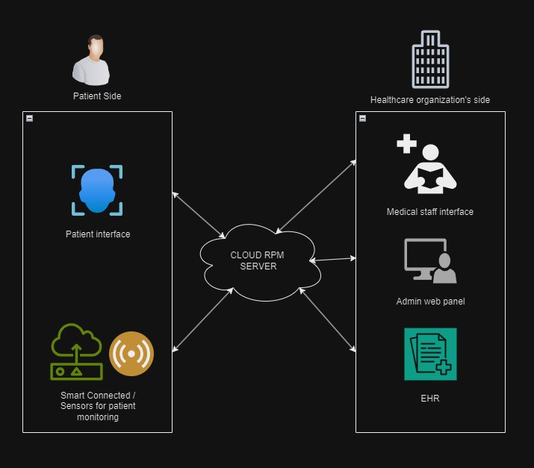

**Figure 3.4.1: Architecture of a Remote Patient Monitoring System**

Figure 3.4.1 shows a remote patient monitoring (RPM) system. It demonstrates integrated components that improve communication between patients, medical personnel, and a cloud-based RPM server. The cloud RPM server serves as a centralized store for patient medical data. Patient data is collected for monitoring reasons via smart linked devices and sensors. Wearables, blood pressure cuffs, and weight scales are some examples of such equipment. The data is subsequently sent securely to the cloud server. The patient is depicted on the diagram's left side. It depicts a patient interface, which apparently lets individuals examine their health information and maybe interact with the system. The medical staff interface is shown on the right side of the figure. This interface allows medical personnel to track patient data, analyze patterns, and perhaps connect with patients. An admin web interface is also provided, most likely for system administrative needs. EHR (Electronic Health Record) is stated in the bottom right, implying that the RPM system may integrate with a healthcare organization's electronic medical records system.

***Benefits and Applications in Chronic Disease Management:***

***i) Continuous Monitoring***: Remote patient tracking allows healthcare practitioners to watch crucial symptoms, signs and symptoms, and medication adherence in actual time, bearing in mind early analysis of health issues and proactive cures for continual issues together with diabetes, high blood pressure, and heart disorder.

***ii) Personalized Care:*** By remotely gathering and analyzing patient statistics, healthcare specialists might also adapt remedy plans, regulate drugs, and offer lifestyle recommendations primarily based on man or woman fitness metrics and developments, assisting individualized care for persistent contamination management.

***iii) Improved Patient Engagement:*** Remote tracking systems inspire sufferers to interact in self-control sports, offer them the capability to take charge of their fitness, and improve communication with healthcare practitioners, creating a collaborative method to treating persistent ailments.

***iv) Cost-Effective Care Delivery:*** Remote affected person monitoring decreases the want for common in-individual visits, hospitalizations, and ER visits, resulting in fee financial savings for healthcare systems and higher aid allocation for persistent illness control.

***Deep Learning for Anomaly Detection and Risk Prediction:***

***i) Anomaly Detection:*** Deep learning algorithms, such as recurrent neural networks (RNNs) and autoencoders, may additionally examine time-series statistics from remote monitoring devices to come across irregularities in patient health parameters, alerting healthcare team of workers to capacity troubles or deviations from typical patterns.

***ii) Risk Prediction:*** Deep studying fashions skilled on longitudinal patient records can are expecting the threat of disease exacerbations, complications, or hospitalizations for individuals with continual conditions, permitting proactive interventions and customized care plans to mitigate risks and improve consequences.

***iii) Early Intervention:*** By leveraging deep mastering for threat prediction, healthcare vendors can discover high-risk patients, stratify people based on their likelihood of unfavorable occasions, and interfere early to save you disorder progression or acute episodes in chronic ailment control.

***iv) Data-pushed Insights:*** Deep learning techniques permit the evaluation of huge volumes of affected person facts, uncovering hidden patterns, correlations, and predictive markers that tell clinical decision-making, treatment techniques, and care coordination for individuals with chronic sicknesses.

**3.5 Federated Learning in Healthcare IoT**

Federated learning in healthcare IoT offers a viable way to guard privacy whilst considering collaborative version education throughout dispersed gadgets and statistics sources. This decentralized system learning paradigm allows one-of-a-kind parties to collaborate and assemble powerful models without revealing touchy records, addressing privateness and statistical protection troubles in healthcare settings.

***Protecting Privacy through National Studies:***

***i) Data localization:*** Federated learning enables prototype training on edge devices or locally in healthcare organizations, ensuring critical patient data remains on-premises and not sent to a central server.

***ii) Secure Storage:*** Federal academic protocols use secure storage techniques to keep model updates from devices while protecting data privacy through encryption, limiting access to unwanted personal data.

***iii) Privacy-Preserving Algorithms:*** Federated studying algorithms, including federated averaging and federated optimization, are designed to protect the privacy of character statistics contributors by way of aggregating version updates in a privacy-preserving way without exposing uncooked records or private information.

***iv) Differential Privacy***: Federated learning frameworks often combine differential privateness mechanisms to add noise or perturbations to version updates, ensuring that character contributions are indistinguishable and defensive the privacy of sensitive healthcare information.

***Applications and Challenges in Collaborative Model Training:***

***i) Multi-Institutional Collaboration:*** Federated getting to know facilitates collaborative model schooling across a couple of healthcare establishments, allowing hospitals, clinics, and research facilities to mutually expand predictive models, scientific choice help equipment, and remedy recommendations without sharing patient records.

***ii) Personalized Healthcare:*** Federated gaining knowledge of permits the creation of customized healthcare fashions that leverage facts from numerous sources while respecting information possession and privacy constraints, main to tailored treatment plans, danger checks, and patient effects predictions.

***iii) Real-Time Monitoring:*** Federated studying in healthcare IoT helps Realtime tracking of affected person information, permitting non-stop version updates, anomaly detection, and predictive analytics without compromising records privateness or protection.

***iv) Regulatory Compliance:*** Challenges in federated learning encompass making sure regulatory compliance with records protection legal guidelines, maintaining facts integrity throughout disbursed structures, and addressing interoperability troubles between different healthcare IoT devices and systems.

**4. Case Studies: Deep Learning Applications in Healthcare IOT**

**4.1 Remote Patient Monitoring:**

***Case Study:*** Healthcare IoT systems are designed to monitor patients remotely with sensors, including wearable devices, smart watches, and home monitoring devices Deep learning systems can analyze data from those devices analyze in real time to detect abnormalities or changes in patients’ health status. For example, deep learning models can analyze ECG data to detect cardiac arrhythmias or other cardiac-related irregularities. This allows for early intervention and immediate care, avoiding the need for multiple hospital visits [19].

**Figure 4.1.1: Remote patient monitoring**

***Problem Statement:*** Create a system for remotely tracking patients health with IoT devices to come across abnormalities and provide activate scientific intervention.

***Methodology:*** Collect patient facts with wearable IoT sensors. Transfer records securely to a cloud platform for analysis. Use deep studying techniques like recurrent neural networks (RNNs) or convolutional neural networks (CNNs) to stumble on abnormalities in actual time. Inform healthcare practitioners whilst anomalies are observed.

***Dataset:*** Wearable IoT gadgets acquire patient health data consisting of critical signs (e.G., coronary heart price, blood stress) and bodily pastime ranges.

***Techniques Used:*** Deep studying strategies (RNNs, CNNs), real-time statistics analytics, and anomaly detection.

***Results:*** Improved performance in remote patient tracking, early detection of health abnormalities, fewer medical institution visits, and higher affected person consequences.

***Conclusion:*** Remote patient tracking with IoT and deep getting to know generation enables proactive healthcare interventions, ensuing in stepped forward patient care and lower healthcare costs.

**4.2 Diagnostic Imaging:**

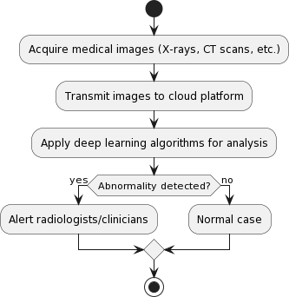***Case Study:*** Medical photographs such as X-rays, CT scans, and MRIs are evaluated using deep learning algorithms to deliver unique diagnoses. In a healthcare IoT situation, those pix may be captured from foreign places and securely shared for evaluation by deep mastering fashions strolling on cloud platforms. Deep studying systems, for instance, can be trained to accurately discover anomalies in chest X-rays, including pneumonia or lung nodules. This lets in for speedier prognosis and treatment planning, in locations with limited get right of entry to radiology [20].

**Figure 4.2.1: Diagnostic Imaging**

***Problem Statement:*** Create an automated system for comparing medical photos (X-rays, CT scans, and many others.) so one can help radiologists spot anomalies extra precisely and efficiently.

***Methodology:*** Obtain medical photographs the usage of various imaging modalities. Send photos securely to a cloud platform for analysis. Use deep gaining knowledge of strategies, along with convolutional neural networks (CNNs), to classify and section photographs. Abnormalities ought to be said to radiologists.

***Dataset:*** A set of clinical photographs (X-rays, CT scans, and MRIs) tagged with ground truth annotations that indicate the presence or absence of anomalies.

***Techniques Used:*** Deep mastering algorithms (CNNs), photograph categorization, segmentation, and pc-assisted diagnostics.

***Results:*** Improved accuracy and efficiency in identifying issues in clinical pix, resulting in less attempt for radiologists, quicker analysis, and treatment making plans.

***Conclusion:*** Deep gaining knowledge of-totally based evaluation of medical pix improves diagnostic competencies, ensuing in higher affected person care and results.

**4.3 Predictive Analytics for Disease Management:**

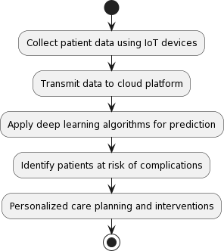***Case Study:*** Healthcare IoT gadgets with sensors constantly capture affected person information inclusive of critical symptoms, activity degrees, and medicine adherence. Deep gaining knowledge of algorithms can use these facts to forecast illness progression and pick out people who are liable to headaches. Deep gaining knowledge of structures, as an instance, may expect blood glucose levels based on a lot of inputs, together with meals, pastime, and insulin dosage. This permits tailored remedy regimens and early interventions to ward off terrible occurrences [21].

**Figure 4.3.1: Predictive Analytics for Disease Management**

***Problem Statement:*** Create predictive algorithms to perceive sufferers prone to problems and tailor remedy strategies for higher ailment management.

***Methodology:*** Collect affected person statistics via IoT gadgets (critical signs and symptoms, medicine adherence, etc.). Send data securely to a cloud platform for evaluation. Use deep learning strategies, together with recurrent neural networks (RNNs) or long brief-time period reminiscence (LSTM) networks, to forecast time-series information. Individualize remedy regimens primarily based on expected risk degrees.

***Dataset:*** Longitudinal patient facts collected via IoT gadgets, EHRs, and different sources.

***Techniques Used:*** Deep learning strategies (RNNs and LSTMs), time series records processing, and predictive modeling.

***Results:*** Early detection of sufferers at threat for troubles, personalized remedy applications, progressed ailment management, and higher affected person results.

***Conclusion:*** Deep getting to know-based totally predictive analytics lets in for preventative remedies and individualized care, ensuing in stepped forward sickness control and affected person effects.

**4.4 Drug Discovery and Development:**

***Case Study:*** Deep learning is used in healthcare IoT to speed up the medication research and development procedures. Deep learning algorithms may find novel drug candidates and forecast their effectiveness and safety profiles by examining large volumes of molecular data, such as genomes, proteomics, and chemical structures. This technique speeds up the drug research pipeline and minimizes the time and expense of bringing new treatments to market. Furthermore, deep learning models may be used to repurpose current medications for new therapeutic indications, increasing therapy choices for a variety of disorders [22].

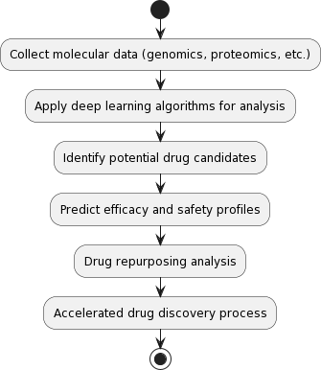**Figure 4.4.1: Drug Discovery and Development**

***Problem Statement:*** Use deep getting to know algorithms to identify feasible drug applicants and forecast their effectiveness and safety characteristics, with a view to help to boost up the drug discovery process.

***Methodology:*** Collect molecular facts (including genomics, proteomics, and chemical structures). Deep mastering techniques, along with deep neural networks (DNNs) and generative hostile networks (GANs), may be used to are expecting chemical properties and carry out digital screening. Validate projected drug candidates with the aid of engaging in in vitro and in vivo tests.

***Dataset:*** Molecular statistics include genetics, proteomics, chemical structures, and present drug databases.

***Techniques Used:*** Deep getting to know techniques (DNNs, GANs), chemical property prediction, and virtual screening.

***Results:*** The drug discovery system is expanded, revolutionary drug candidates are identified, and drug improvement time and price are decreased.

***Conclusion:*** Deep mastering speeds drug discovery with the aid of predicting chemical attributes and finding feasible drug candidates, making an allowance for quicker improvement of novel drugs.

**4.5 Personalized Medicine:**

*****Case Study:*** Healthcare IoT platforms gather numerous records approximately person patients, such as genetic statistics, clinical records, lifestyle factors, and environmental exposures. Deep mastering algorithms analyze these multidimensional records to tailor treatment plans and interventions in keeping with every affected person’s unique trait and need. For example, deep learning algorithms may also be expecting perfect medicine doses based totally on genetic markers and physiological elements, decreasing the hazard of unfavorable drug responses, and improving treatment effects [23].

**Figure 4.5.1: Personalized Medicine**

***Problem Statement:*** Create tailor-made remedy plans for each affected person primarily based on their genetics, medical records, way of life alternatives, and different applicable records.

***Methodology:*** Gather affected person records from a number of sources (genetic assessments, medical statistics, life-style surveys, and many others.). Use deep mastering techniques, including deep neural networks (DNNs) or reinforcement studying (RL), to integrate information and offer individualized treatments. Validate treatment strategies the usage of medical trials and patient comments.

***Dataset:*** Patient facts may encompass genetic data, medical facts, way of life variables, and remedy consequences.

***Techniques Used:*** Deep mastering algorithms (DNNs, RL), statistics integration, and personalized therapy recommendations.

***Results:*** Personalized remedy methods based totally on specific patient characteristics result in better treatment results and elevated affected person delight.

***Conclusion:*** Deep gaining knowledge of allows custom designed remedy via integrating several patient facts resources and offering precise treatment strategies, resulting in advanced affected person results and satisfaction.

**5. Challenges and Future Direction**

**5.1 Safeguarding Data Privacy and Security**

Data privateness and security are vital troubles when using deep learning (DL) algorithms in healthcare Internet of Things (IoT) structures. The sensitive nature of medical facts, which incorporates affected person data, pictures, and genetic statistics, demands sturdy protections against unwanted access, breaches, and abuse. Compliance with facts protection rules, including the Health Insurance Portability and Accountability Act (HIPAA), is essential for retaining patient confidentiality and self-belief in healthcare systems.

One of the primary demanding situations lies in safeguarding the privateness and security of touchy healthcare statistics as it is transferred and stored on IoT gadgets, mainly while utilizing deep getting to know models for evaluation [24][25]. To address this task, it is crucial to hire robust encryption techniques, secure communique protocols, and get entry to manage structures to protect affected person records. Additionally, the development of privacy-keeping deep learning techniques, consisting of federated mastering, can allow collaborative evaluation without compromising facts privateness.

Implementing strong facts privacy and security measures is imperative to save you unauthorized get entry to, breaches, and misuse of sensitive healthcare statistics. By making sure compliance with guidelines like HIPAA and using advanced technology together with encryption and federated mastering, healthcare groups can beautify records protection and maintain affected person confidentiality and trust of their systems.

**5.2 Understanding Deep Learning Models**

The explainability and interpretability of deep getting to know (DL) models are important in healthcare packages in which selections would possibly have far-attaining repercussions. DL fashions are commonly known as black packing containers, making it hard to recognize how they produce positive predictions or diagnoses. This opacity can erode self-assurance among healthcare practitioners and sufferers, as individuals ought to understand the logic at the back of their healthcare selections. Improving the explainability and interpretability of deep learning fashions is important to increasing transparency and self-assurance in healthcare AI systems.

One of the important thing challenges in healthcare AI is ensuring that DL fashions are interpretable and explainable. Without this, healthcare vendors can be hesitant to undertake these technologies for fear of making decisions based totally on incomprehensible or untrustworthy facts. To cope with this venture, studies efforts are specializing in growing procedures to make DL fashions more interpretable, in particular in important healthcare contexts [26][27]. These efforts goal to offer insights into how DL fashions make judgments, increasing transparency and fostering trust between healthcare specialists and sufferers.

Future guidelines on this place include extending research into explainable AI to decorate the interpretability of DL fashions in healthcare. By developing tactics that offer reasons for DL version choices, healthcare carriers can more apprehend the motive behind those selections, leading to extra knowledgeable and confident decision-making. This, in turn, can enhance patient consequences and basic healthcare shipping.

**5.3 Navigating Regulatory Compliance**

Ensuring regulatory compliance is a tough and vital factor of deploying deep learning (DL) technologies in healthcare Internet of Things (IoT) settings. Adherence to regulatory norms and guidelines is essential to making sure the criminal and moral utilization of deep getting to know algorithms in medical contexts. This involves ensuring statistical safety, patient consent, set of rules validation, and moral problems. Regulatory compliance is essential for constructing self-belief with sufferers and healthcare vendors, as well as avoiding legal ramifications.

One of the principal hurdles in deploying DL-based solutions in healthcare IoT is negotiating the dense internet of healthcare legal guidelines and requirements, along with policies like HIPAA, GDPR, and FDA pointers [14][17][18]. Compliance with these rules requires cautious consideration of facts protection, affected person consent, and algorithm validation methods. Achieving compliance includes not simplest know-how those guidelines however additionally implementing measures to make certain that DL applications in healthcare IoT adhere to felony requirements. This task underscores the need for collaboration among era developers, healthcare companies, and regulatory bodies to increase pointers that promote the moral and felony use of DL in healthcare.

Moving ahead, efforts to deal with this challenge need to include operating closely with regulatory businesses to increase pointers for the moral utility of DL in healthcare. This collaboration can assist in setting up clear pointers for the design, improvement, and deployment of DL-based solutions in healthcare IoT contexts. Furthermore, integrating compliance measures into the design and deployment of IoT structures can make certain regulatory compliance and protect affected person rights. Healthcare corporations can also profit from DL technology whilst keeping agree with and self-assurance in their services through addressing regulatory compliance and moral problems.

**5.4 Scalability and Interoperability**

Scalability and interoperability are pivotal demanding situations inside the integration of deep gaining knowledge of (DL) models into massive-scale healthcare structures and IoT ecosystems. The exponential boom of records in healthcare settings necessitates DL algorithms that may correctly cope with increasing information volumes without compromising overall performance. Additionally, interoperability throughout diverse systems, gadgets, and platforms is vital for seamless statistics change, collaboration, and generation integration in healthcare IoT environments. Scaling deep getting to know fashions to meet the desires of massive-scale healthcare structures is a considerable trouble. As statistics volumes increase, deep learning algorithms ought to be able to correctly take care of and analyze big quantities of facts even as preserving high overall performance degrees. Achieving scalability requires the development of optimized algorithms, hardware infrastructure, and facts control strategies to support the developing demands of healthcare IoT applications [7][8][9].

Interoperability is some other essential challenge in healthcare IoT ecosystems, where records trade between distinctive systems, devices, and systems is critical for effective healthcare transport. Ensuring that DL fashions are interoperable throughout a wide range of healthcare IoT devices, systems, and data assets is crucial for allowing seamless records interchange and collaboration. Future efforts need to cognizance on developing standardized protocols and frameworks that facilitate the mixing of DL algorithms with IoT infrastructure, selling interoperability and allowing smoother facts exchange between healthcare structures. Improving version portability and versatility in a lot of IoT situations is likewise important for enhancing DL model adoption and interoperability in healthcare. By addressing these scalability and interoperability worries, healthcare organizations may also fully gain DL generation's capacity of enhancing patient care, scientific results, and promoting innovation in healthcare shipping.

**5.5 Future Trends in Deep Learning for Healthcare IoT**

Personalized remedy, enabled through advanced deep gaining knowledge of algorithms, represents a transformative approach to healthcare. By leveraging affected person-precise facts, genetic profiles, and life-style variables, deep mastering fashions can tailor remedy plans and actions to character desires [7][8][9]. This method has great potential for improving patient effects and maximizing healthcare charges because it ensures that therapies aren't only effective but additionally tailor-made to every patient's specific development. Integration of deep getting to know models with facet computing is every other vast advancement in healthcare IoT applications [7][8][9]. Edge computing lets in for actual- time evaluation, lowers latency, and improves privateness by processing statistics in the direction of its supply. This is mainly critical in healthcare, where spark off choice-making and records security are crucial. The combination of deep gaining knowledge of and aspect computing is remodeling healthcare with the aid of supplying extra green and steady facts processing, which results in progressed patient consequences.

Ethical troubles are at the vanguard of deep studying in healthcare, considering that the use of AI increases essential questions on fairness, transparency, and obligation [26][27][28]. Ethical AI in healthcare makes a specialty of ensuring that deep getting to know systems are designed and implemented in a way that respects affected person autonomy, protects affected person data, and promotes equity in healthcare shipping. By addressing these ethical concerns, healthcare institutions may additionally foster patient self-assurance at the same time as additionally ensuring that AI is utilized ethically to enhance results. Another key development in healthcare AI is multimodal information fusion, this involves combining information from many resources, consisting of imaging, genomics, and sensor data, to assemble complete fashions for infection diagnosis, diagnosis, and individualized healthcare control [14][17][18]. This approach enables healthcare carriers to benefit an extra holistic view of patient health and make more informed selections approximate treatment and care.

Personalized medicine, ethical AI, edge computing, and multimodal facts fusion are using huge advancements in healthcare. By harnessing the power of deep gaining knowledge of and integrating it with contemporary technologies, healthcare carriers can supply more personalized, green, and ethical care, in the long run improving patient effects and remodeling the healthcare panorama.

**6. Conclusion**

The aggregate of deep studying with healthcare IoT represents a breakthrough method to customized medicinal drug, moral AI, and green facts processing. Healthcare practitioners may additionally adapt remedy regimens, hold statistics security, and beautify patient outcomes by means of combining affected person-specific statistics with modern technology inclusive of part computing. The moral implications of AI in healthcare spotlight the significance of openness, justice, and patient autonomy in decision-making approaches. Multimodal records fusion improves the general photo of patient fitness, making an allowance for better knowledgeable treatment choices and individualized care. Overall, advances in personalized remedy, moral AI, side computing, and multimodal facts fusion are changing the healthcare surroundings with the aid of offering extra green, secure, and ethical answers.

Moving forward, the sector of healthcare IoT can take advantage of numerous key regions of enhancement. Firstly, the development of explainable AI tactics can enhance the interpretability of deep studying fashions, fostering trust among healthcare experts and patients. By presenting causes for version decisions, healthcare vendors can make more knowledgeable selections, main to higher affected person consequences. Secondly, navigating regulatory compliance stays crucial, requiring collaboration between stakeholders to set up clean suggestions for the ethical use of deep mastering in healthcare. Emphasizing information safety, patient consent, and set of rules validation methods is important for maintaining agree with and legal compliance.

Furthermore, the scalability and interoperability problems of incorporating deep studying fashions into healthcare structures necessitate sturdy IoT answers capable of managing the expanding quantity of data at the same time as keeping faultless connection between gadgets. Patient participation can be improved through tailored remedy plans and Realtime tracking systems, allowing people to take a lively position of their personal health control. Strengthening records protection and privateness safeguards is essential for shielding touchy affected person data and retaining self-belief in healthcare services.

The destiny of healthcare IoT is to sell deep studying era for higher affected person care, operational performance, and innovation in the healthcare industry. Healthcare companies may additionally harness the potential of deep studying by addressing moral issues, prison limits, and scalability challenges. Collaboration between era developers, healthcare vendors, and regulatory bodies is important for encouraging the perfect and moral use of AI in healthcare, in the end improving affected person consequences, and changing the panorama.

**References**

[1] X. Qian, H. Chen, H. Jiang, J. Green, H. Cheng, and M.-C. Huang, “Wearable Computing With Distributed Deep Learning Hierarchy: A Study of Fall Detection,” IEEE Sensors Journal, vol. 20, no. 16, pp. 9408–9416, Aug. 2020, doi: 10.1109/jsen.2020.2988667.

[2] S. Atiewi et al., “Scalable and Secure Big Data IoT System Based on Multifactor Authentication and Lightweight Cryptography,” IEEE Access, vol. 8, pp. 113498–113511, 2020, doi: 10.1109/access.2020.3002815.

[3] A. A. Abdellatif, N. Mhaisen, A. Mohamed, A. Erbad, and M. Guizani, “Reinforcement Learning for Intelligent Healthcare Systems: A Review of Challenges, Applications, and Open Research Issues,” IEEE Internet of Things Journal, vol. 10, no. 24, pp. 21982–22007, Dec. 2023, doi: 10.1109/jiot.2023.3288050.

[4] A. Rauniyar et al., “Federated Learning for Medical Applications: A Taxonomy, Current Trends, Challenges, and Future Research Directions,” IEEE Internet of Things Journal, vol. 11, no. 5, pp. 7374–7398, Mar. 2024, doi: 10.1109/jiot.2023.3329061.

[5] M. Ali, F. Naeem, M. Tariq, and G. Kaddoum, “Federated Learning for Privacy Preservation in Smart Healthcare Systems: A Comprehensive Survey,” IEEE Journal of Biomedical and Health Informatics, vol. 27, no. 2, pp. 778–789, Feb. 2023, doi: 10.1109/jbhi.2022.3181823.

[6] S. Ghosh and S. K. Ghosh, “FEEL: FEderated LEarning Framework for ELderly Healthcare Using Edge-IoMT,” IEEE Transactions on Computational Social Systems, vol. 10, no. 4, pp. 1800–1809, Aug. 2023, doi: 10.1109/tcss.2022.3233300.

[7] Z. Chkirbene, A. A. Abdellatif, A. Mohamed, A. Erbad, and M. Guizani, “Deep Reinforcement Learning for Network Selection Over Heterogeneous Health Systems,” IEEE Transactions on Network Science and Engineering, vol. 9, no. 1, pp. 258–270, Jan. 2022, doi: 10.1109/tnse.2021.3058037.

[8] A. Singh, G. S. Aujla, S. Garg, G. Kaddoum, and G. Singh, “Deep-Learning-Based SDN Model for Internet of Things: An Incremental Tensor Train Approach,” IEEE Internet of Things Journal, vol. 7, no. 7, pp. 6302–6311, Jul. 2020, doi: 10.1109/jiot.2019.2953537.

[9] S. U. Amin and M. S. Hossain, “Edge Intelligence and Internet of Things in Healthcare: A Survey,” IEEE Access, vol. 9, pp. 45–59, 2021, doi: 10.1109/access.2020.3045115.

[10] V. Hayyolalam, M. Aloqaily, O. Ozkasap, and M. Guizani, “Edge-Assisted Solutions for IoT-Based Connected Healthcare Systems: A Literature Review,” IEEE Internet of Things Journal, vol. 9, no. 12, pp. 9419–9443, Jun. 2022, doi: 10.1109/jiot.2021.3135200.

[11] Y. Pan, M. Fu, B. Cheng, X. Tao, and J. Guo, “Enhanced Deep Learning Assisted Convolutional Neural Network for Heart Disease Prediction on the Internet of Medical Things Platform,” IEEE Access, vol. 8, pp. 189503–189512, 2020, doi: 10.1109/access.2020.3026214.

[12] M. Izhar, S. A. A. Naqvi, A. Ahmed, S. Abdullah, N. Alturki, and L. Jamel, “Enhancing Healthcare Efficacy Through IoT-Edge Fusion: A Novel Approach for Smart Health Monitoring and Diagnosis,” IEEE Access, vol. 11, pp. 136456–136467, 2023, doi:10.1109/access.2023.3337092.

[13] D. Saraswat et al., “Explainable AI for Healthcare 5.0: Opportunities and Challenges,” IEEE Access, vol. 10, pp. 84486–84517, 2022, doi: 10.1109/access.2022.3197671.

[14] S. Sakib et al., “Deep Learning Models for Magnetic Cardiography Edge Sensors Implementing Noise Processing and Diagnostics,” IEEE Access, vol. 10, pp. 2656–2668, 2022, doi: 10.1109/access.2021.3138976.

[15] A. Gutierrez-Torre et al., “Automatic Distributed Deep Learning Using ResourceConstrained Edge Devices,” IEEE Internet of Things Journal, vol. 9, no. 16, pp. 15018–15029, Aug. 2022, doi: 10.1109/jiot.2021.3098973.

[16] U. S. Toro, K. Wu, and V. C. M. Leung, “Backscatter Wireless Communications and Sensing in Green Internet of Things,” IEEE Transactions on Green Communications and Networking, vol. 6, no. 1, pp. 37–55, Mar. 2022, doi: 10.1109/tgcn.2021.3095792.

[17] S. Arisdakessian, O. A. Wahab, A. Mourad, H. Otrok, and M. Guizani, “A Survey on IoT Intrusion Detection: Federated Learning, Game Theory, Social Psychology, and Explainable AI as Future Directions,” IEEE Internet of Things Journal, vol. 10, no. 5, pp. 4059–4092, Mar. 2023, doi: 10.1109/jiot.2022.3203249.

[18] I. Ahmed, A. Ahmad, and G. Jeon, “An IoT-Based Deep Learning Framework for Early Assessment of Covid-19,” IEEE Internet of Things Journal, vol. 8, no. 21, pp. 15855–15862, Nov. 2021, doi: 10.1109/jiot.2020.3034074.

[19] D. Ravi et al., “Deep Learning for Health Informatics,” IEEE Journal of Biomedical and Health Informatics, vol. 21, no. 1, pp. 4–21, Jan. 2017, doi: 10.1109/jbhi.2016.2636665.

[20] A. Esteva et al., “Dermatologist-level classification of skin cancer with deep neural networks,” Nature, vol. 542, no. 7639, pp. 115–118, Jan. 2017, doi: 10.1038/nature21056.

[21] A. Rajkomar et al., “Scalable and accurate deep learning with electronic health records,” npj Digital Medicine, vol. 1, no. 1, May 2018, doi: 10.1038/s41746-018-0029-1.

[22] G. Schneider, “Automating drug discovery,” Nature Reviews Drug Discovery, vol. 17, no. 2, pp. 97–113, Dec. 2017, doi: 10.1038/nrd.2017.232.

[23] B. Shickel, P. J. Tighe, A. Bihorac, and P. Rashidi, “Deep EHR: A Survey of Recent Advances in Deep Learning Techniques for Electronic Health Record (EHR) Analysis,” IEEE Journal of Biomedical and Health Informatics, vol. 22, no. 5, pp. 1589–1604, Sep. 2018, doi: 10.1109/jbhi.2017.2767063.

[24] “Healthcare Monitoring and Concurrent Medical Service Consultation using Deep Learning and Optimization Techniques in IoMT,” IEEE Conference Publication | IEEE Xplore, Nov. 25, 2022. https://doi.org/10.1109/INCOFT55651.2022.10094325

[25] I. Azimi, J. Takalo-Mattila, A. Anzanpour, A. M. Rahmani, J.-P. Soininen, and P. Liljeberg, “Empowering healthcare IoT systems with hierarchical edge-based deep learning,” Sep. 26, 2018. https://doi.org/10.1145/3278576.3278597

[26] “Smart Healthcare in IoT using Convolutional Based Cyber Physical System,” IEEE Conference Publication | IEEE Xplore, Oct. 16, 2022. https://doi.org/10.1109/MysuruCon55714.2022.9972679

[27] “An IoT Based Heart Healthcare Platform for the Sultanate of Oman,” IEEE Conference Publication | IEEE Xplore, Oct. 27, 2022. https://doi.org/10.1109/MAJICC56935.2022.9994183

[28] “IoMT-Enabled Smart Healthcare: State-of-the-Art, Security and Future Directions,” IEEE Conference Publication | IEEE Xplore, Dec. 26, 2023. https://doi.org/10.1109/IKT62039.2023.10433013

[29] W. N. Ismail, M. M. Hassan, H. A. Alsalamah, and G. Fortino, “CNN-Based Health Model for Regular Health Factors Analysis in Internet-of-Medical Things Environment,” IEEE Access, vol. 8, pp. 52541–52549, 2020, doi: 10.1109/access.2020.2980938.

[30] M. Aledhari, R. Razzak, R. M. Parizi, and F. Saeed, “Federated Learning: A Survey on Enabling Technologies, Protocols, and Applications,” IEEE Access, vol. 8, pp. 140699–140725, 2020, doi: 10.1109/access.2020.3013541.